**ggplot2**

**Grammar of Graphics**

2 principles

1. Graphics = distinct layers of grammatical elements
2. Meaningful plots through aesthetic mapping

|  |  |
| --- | --- |
|  |  |

ggplot(mtcars, aes(x = wt, y = mpg)) + geom_point()

ggplot(mtcars, aes(x = wt, y = mpg, **color** = disp)) + geom_point()

ggplot(mtcars, aes(x = wt, y = mpg, **size** = disp)) + geom_point()

|  |  |
| --- | --- |
|  |  |

**Data**

iris.wide (pg15) & iris.tidy (pg23) & facet_grid()

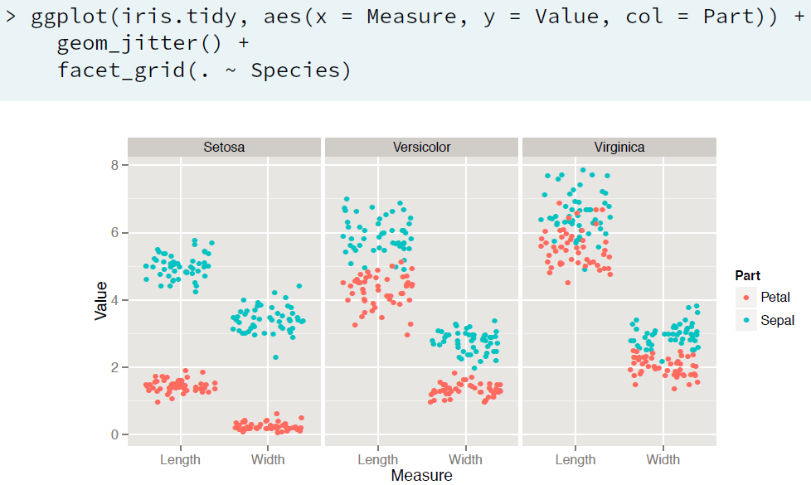

**Aesthetics Layer**

* Column can be mapped onto visible ***aesthetic***
* Aesthetics in aes(), ***attributes*** in geom_(col=”red”)
* aes() can also be called in geom_(), but done usually when you want to include multiple data sources
* ggplot(mtcars, aes(x=wt, y=mpg, fill=cyl, col=am)) + geom_point(**shape**=21, **size**=4, **alpha**=0.6)
  + aes has to be associated with columns
  + attributes are given along with geom_*() and don’t have columns associated with them
* ggplot(mtcars, aes(x = wt, y = mpg, fill = cyl, **label**=rownames(mtcars))) + geom_**text**(color='red')
* **Modifying Aesthetics**
  + geom_bar(**postion**=”< stack, fill, dodge, … >”)
  + **scale_\*** functions
    - scale_x/y_continuous/discrete(“title”, limits, breaks, expand, ….)
    - ex: scale_x_continuous(“x-axis”, limits=c(0,10), breaks=seq(0,10,2))
  + **labs**(x,y,col, …)

|  |  |
| --- | --- |
| Aesthetics for Continuous Variables | Aesthetics for Categorical Variables |

**Geometry Layer**

**Scatter Plots**: geom_point()

* aes() inside geom_*() can be used to use different aesthetics for different layer of geom_*() . Same goes for different data for different geom_*()
* aes() inside geom_*() is same as aes() in ggplot()

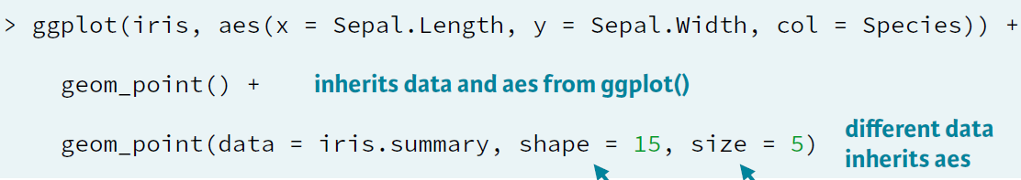

* ggplot(iris, aes(x = Sepal.Length, y = Sepal.Width, col = Species)) + geom_**jitter**(**shape**=1, **alpha**=0.6)
  + to visualize the density, use jitter along with alpha & shape(hollow shapes preferred)

**Bar Plots:**

* **Histogram**: geom_histogram() : x-axis : continuous variables
  + ggplot(df, aes(x=x1)) + geom_histogram(**binwidth**=0.1)
  + ggplot(df, aes(x=x1)) + geom_histogram(aes(y=**..density..**), binwidth=0.1)
  + ggplot(df, aes(x=x1, fill=cat_var)) + geom_histogram(binwidth=0.1, **position**=”stack/fill/dodge”)

|  |  |  |
| --- | --- | --- |
|  |  |  |

* **Bar Plot**: geom_bar() : x-axis = categorical variables
  + ggplot(df, aes(x=cat_var)) + geom_bar(stat=”bin”)
  + Custom Color Palettes

blues <- brewer.pal(9, "Blues")

blue_range <- colorRampPalette(blues)

ggplot(Vocab, aes(x = education, fill = vocabulary)) +

geom_bar(position = "fill") +

scale_**fill_manual**(**values**=blue_range(11))

* + Overlapping bar plots

posn_d <- **position_dodge**(**width**=0.2)

ggplot(mtcars, aes(x = cyl, fill = am)) + geom_bar(position=posn_d)

* **Line Plots:** geom_line()
  + Plotting different categories

ggplot(df, aes(x=Year, y=Capture, **linetype**=Species)) + geom_line()

* + Proportional Trends

ggplot(df, aes(x=Year, y=Capture, **fill**=Species)) + geom_**area**(position=”fill”)

* + ggplot(economics, aes(x=date, y=unemploy/pop)) + **geom_rect**(data=recess, aes(xmin=begin, xmax=end, ymin=-Inf, ymax=+Inf), **inherit.aes=FALSE**, fill="red", alpha=0.2) + geom_line()

**qplot**

* Quick and dirty way for plotting, not very flexible, doesn’t follow grammar of graphics
* qqplot( x, y, data, shape/size/col, postion, jitter, alpha=I(value) )

**Wrap-Up**

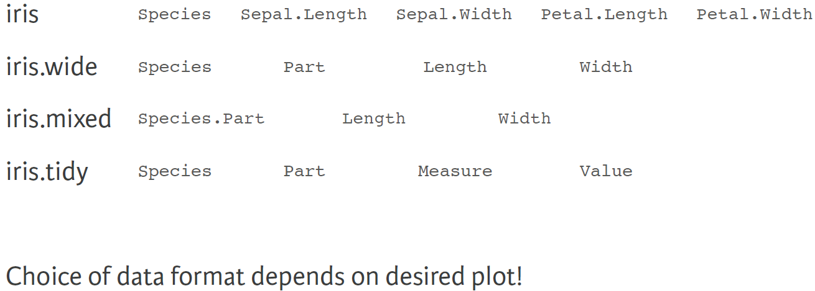

**Statistics Layer**

* Two types: called within a geom and called independtly

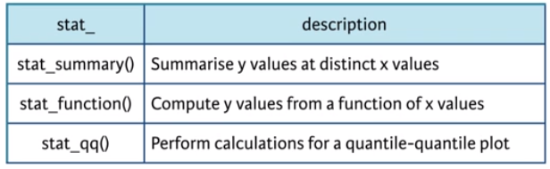

* **stat_smooth**(method=”loess/lm/…”, se, aes(group=1, col=”text”), span)
  + ex: ggplot(Vocab, aes(x = education, y = vocabulary, col = year, group = factor(year))) +

stat_smooth(method = "lm", se = FALSE, alpha = 0.6, size = 2) +

scale_color_gradientn(colors = brewer.pal(9, "YlOrRd"))

* **stat_summary**(geom=”***errorbar***”, fun.data=mean_sdl, fun.args=list(…), witdh) # adds error bars
* **stat_summary**(geom=”***point***”, fun.y=mean) # adds point for the mean values
* **stat_summary**(geom="***linerange***", fun.data =<custom_function>, position=posn.d, size=3)
* **stat_function**(fun=dnorm, colour, arg=list(…))

­

**Coordinate Layer**

* zooming-in : + coord_cartesian(xlim=c(4.5, 5.5))
* aspect ratio : + coord_fixed(0.055)

**Facets Layer**

* … + facet_grid(row ~ column)

**Themes Layer**

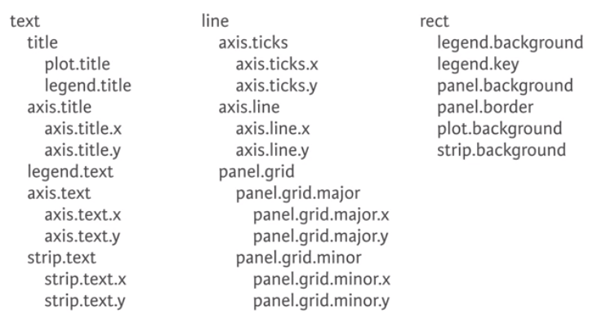

* … + theme(plot.background=element_rect(color=”black”, size=3))
* … + theme(panel.grid=element_line(color=”red”))
* … + theme(axis.text=element_text(color=”red”))
* my.theme <- theme( … )
* theme_update( … )
* theme_set( … )